**BRM**

**LAB EXERCISE 9 (BY-AMAN TYAGI)**

Aim: Build Profile using Maven

1)Creating Project my-app

Run the command:

mvn archetype:generate -DgroupId=com.mycompany.app -DartifactId=my-app

-Darchetyp eArtifactId=maven-archetype-quickstart -DarchetypeVersion=1.4

-DinteractiveMode=false

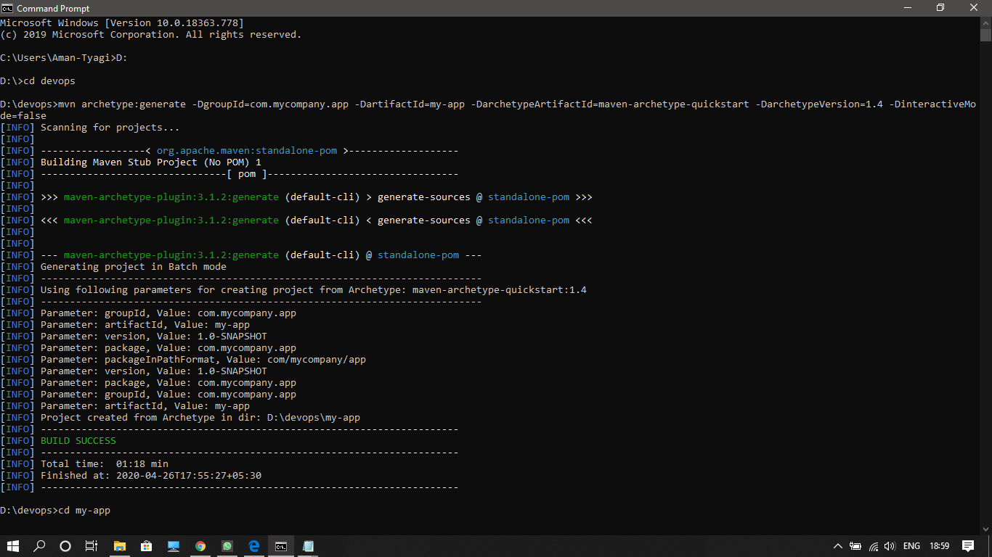

**Explicit Profile Activation**

Adding profile1 in pom.xml file:

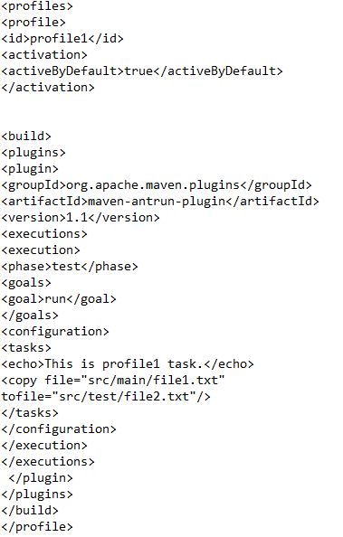

Run on console:

mvn test -Pprofile1

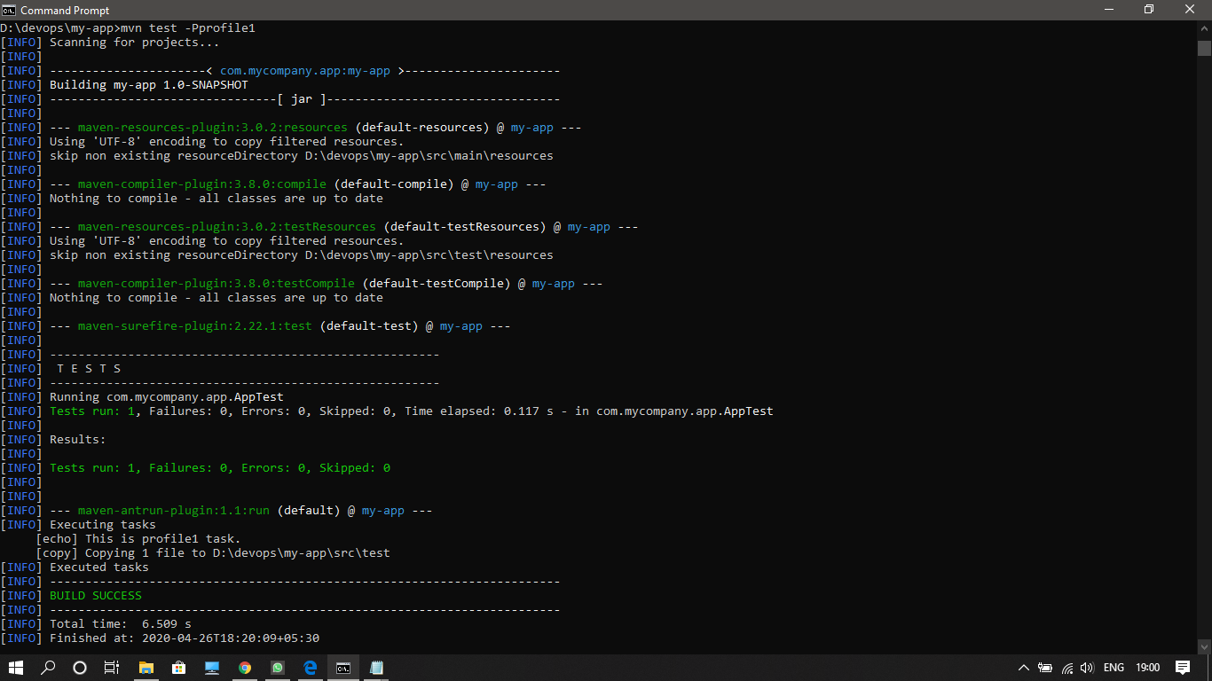

Similarly adding profile2 in pom.xml:

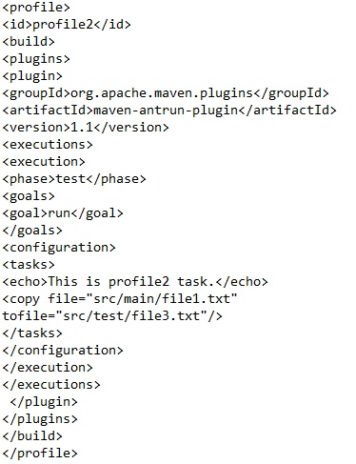

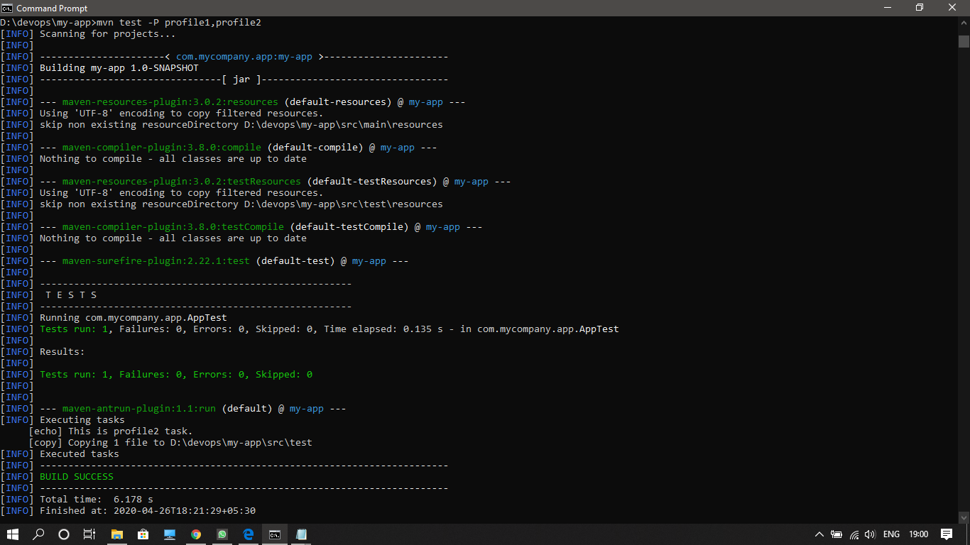

**Profile Activation via Maven Settings**

settings.xml file:

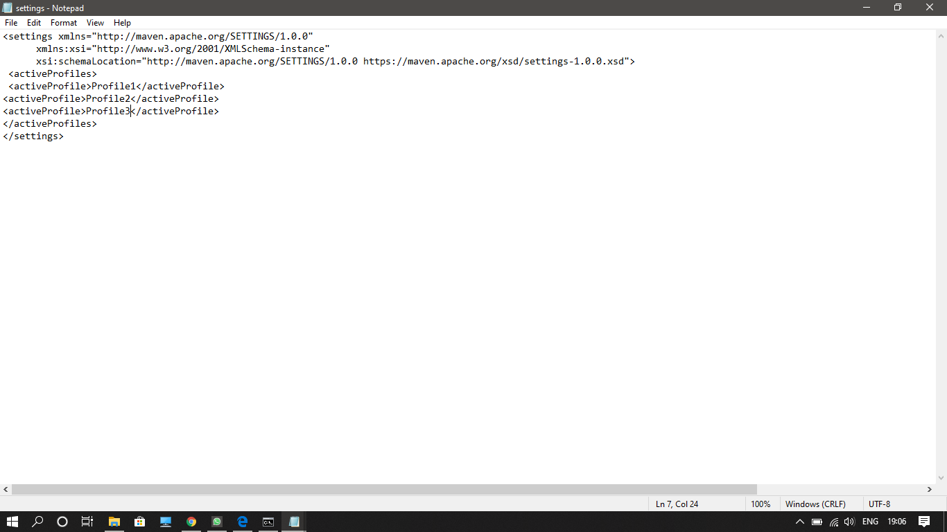

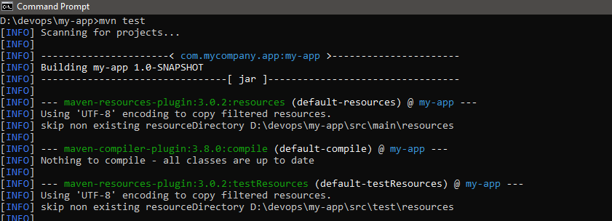

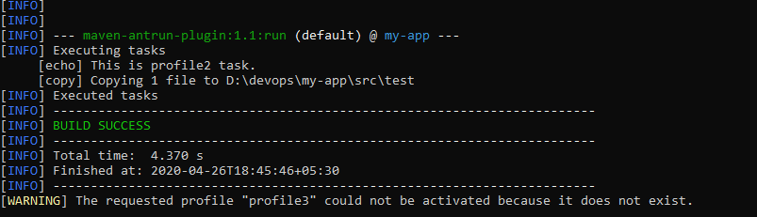

**Profile Activation via Environment Variables**

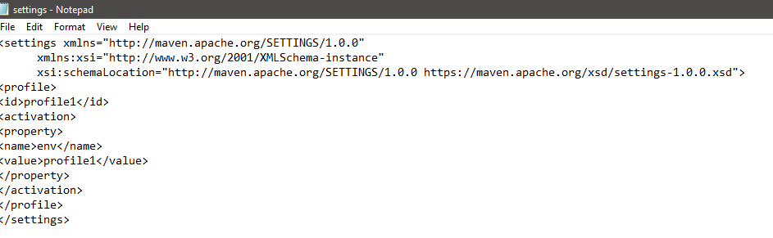

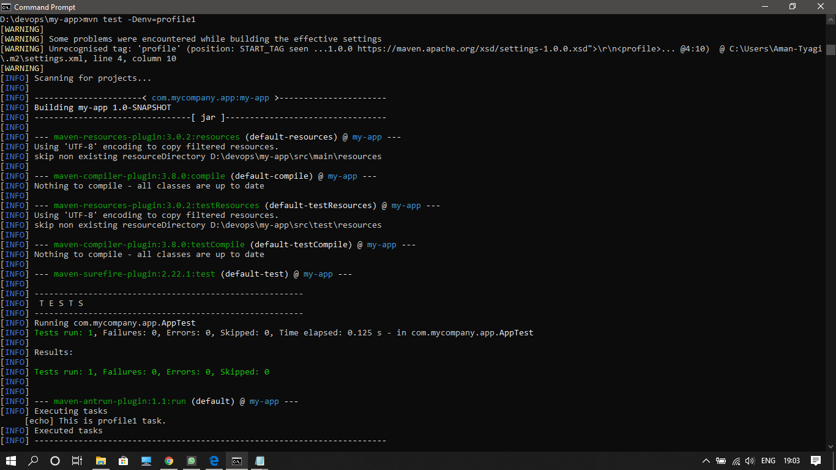

**Profile Activation via Present/Missing File**

